**LATOYA V. ZAVALA**

**LIEUTENANT, CHAPLAIN CORPS, UNITED STATES NAVY**

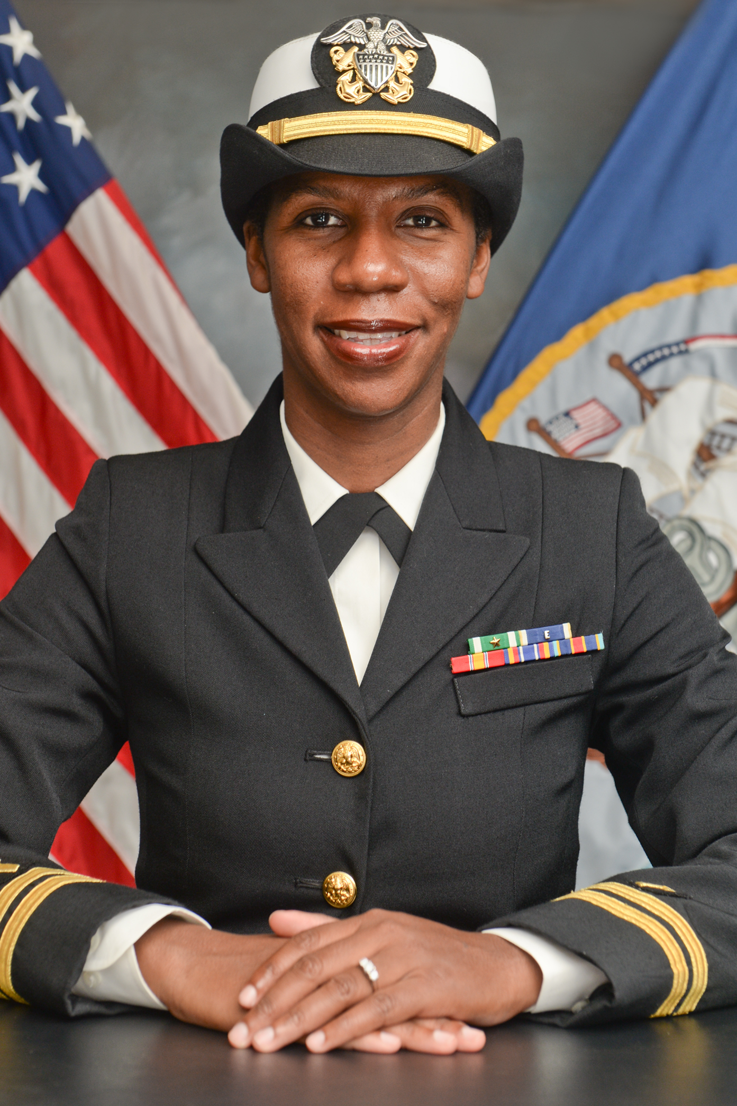Chaplain Zavala is a native of Boston, MA. In 2005, she earned a Bachelor of Arts degree in Pastoral Theology with a minor in Biblical Languages from Southwestern Adventist University (Keene, TX). She went on to earn a Master of Divinity degree from Regent University in 2012 (Virginia Beach, VA). She has also completed 5 units of Clinical Pastoral Education at Sentara Norfolk General (Norfolk, VA, 2010-2011). She is an ordained minister, endorsed by the Evangelical Church Alliance.

Chaplain Zavala officially began her Navy Chaplain Candidacy as an Ensign in July, 2011. She completed Officer Development School as a candidate in December of 2011 (Newport, RI). In December of 2012, she was commissioned a Lieutenant Junior Grade in the Navy Chaplain Corps and went on to complete Navy Chaplain School in April of 2013 (Columbia, SC). In the same month she reported for a 36 month assignment at Marine Corps Air Station Chapel, Iwakuni, Japan where she was promoted to the rank of Lieutenant and where she served as the interim command chaplain for half of her tour. She then reported to the USS Mobile Bay (CG 53) in MAY 2016. During that tour she deployed with DESRON 21 to the South China Sea and participated in the RIMPAC exercise, providing ministry underway to three destroyers and the DESRON command crew, while providing support for the aircraft carrier. She reported to Naval Base Point Loma in July 2017 as command chaplain, where she currently provides ministry for the base, facilitates ministry for 74 tenant commands, and collaborates with CSS 11 Sub-squadron and SARP/OASIS to provide consistent ministry.

Her personal awards include 2 Navy Commendation Awards.

Chaplain Zavala is happily married to Crisogono ZavalaPena, IT1 (SW/IDW), retired, for 17 years. Together they have a 10 year-old son, John, and a 7 month-old daughter, Julia.